Python Lab Test 2

# Program 1: COVID vaccination Drive Registration

## Code

"""

Details to enter

------------------------

PERSONAL INFO

- First name

- Last name

- DOB (calculated age must be 18 or above)

------------------------

CONTACT INFO

- Phone number (10 digits, non-zero 1st digit)

- E-mail address

- Split string by '@' must result in 2 substrings

- 1st substring must be more than 0 length

- 1st substring must be alphanumeric

(may have characters '.' and '_')

- 2nd substring must contain

- 1 domain name

- 1 extension

(separated by '.')

------------------------

LOCATION INFO

- PIN code (6 digits only)

- City (selection list ideally, but not feasible in time constraint)

- State (selection list ideally, but not feasible in time constraint)

========================

ORDER OF IMPORTANCE

1. CONTACT INFO (can help reveal personal & location details)

2. PERSONAL INFO (to identify user)

3. LOCATION INFO (to give appropriate vaccination locations)

"""

*# INTERFACE*

*# Libraries and modules required*

from tkinter import *

from tkinter.ttk import Combobox

from tkinter.ttk import Separator

*# Root window...*

root = Tk()

root.title("COVID Vaccine Drive Registration")

root.geometry("300x600")

*#========================*

*# LABELS*

*# Contact info labels*

contactInfoLabels = [

Label(root, text = "Phone"),

Label(root, text = "E-mail")]

*#------------------------*

*# Personal info labels*

personalInfoLabels = [

Label(root, text = "First name"),

Label(root, text = "Last name"),

Label(root, text = "DOB date"),

Label(root, text = "DOB month"),

Label(root, text = "DOB year")]

*#------------------------*

*# Location info labels*

locationInfoLabels = [

Label(root, text = "PIN code"),

Label(root, text = "City"),

Label(root, text = "State")]

*#========================*

*# INPUT BOXES*

*# Contact info inputs*

contactInfoInputs = [

Entry(root),

Entry(root)]

*#------------------------*

*# Personal info inputs*

*#____________*

*# DATE INPUTS*

personalInfoInputs = [

Entry(root),

Entry(root),

Spinbox(root, from_ = 1, to = 31, width = 6, wrap = True),

Combobox(root, values = list(range(1, 13)), width = 6),

Entry(root, width = 9)]

*#------------------------*

*# Location info labels*

locationInfoInputs = [

Entry(root, text = "PIN code"),

Entry(root, text = "City"),

Entry(root, text = "State")]

*#========================*

*# PACKING WIDGETS*

*# Contact info*

Label(root, text = "CONTANT INFO", font = ("Helvetica Bold", 15)).pack()

for i in range(len(contactInfoLabels)):

contactInfoLabels[i].pack()

contactInfoInputs[i].pack()

*#------------------------*

*# Personal info*

Label(root, text = "PERSONAL INFO", font = ("Helvetica Bold", 15)).pack()

for i in range(len(personalInfoLabels)):

personalInfoLabels[i].pack()

personalInfoInputs[i].pack()

*#------------------------*

*# Location info*

Label(root, text = "LOCATION INFO", font = ("Helvetica Bold", 15)).pack()

for i in range(len(locationInfoLabels)):

locationInfoLabels[i].pack()

locationInfoInputs[i].pack()

*#========================*

*# SUBMISSION*

from re import *

from datetime import date

from tkinter import messagebox

*# Contact info checks*

**def** checkEmail():

if search(**r**"[^\s]+@(gmail|yahoo|outlook).com$", contactInfoInputs[1].get()):

return True

return False

**def** checkPhone():

if search(**r**"\d{10,11}", contactInfoInputs[0].get()):

return True

return False

*# Personal info checks*

**def** checkName():

if search(**r**"[^\s]+", personalInfoInputs[0].get()):

if search(**r**"[^\s]+", personalInfoInputs[1].get()):

return True

return False

**def** checkDate():

try:

d = int(personalInfoInputs[2].get())

m = int(personalInfoInputs[3].get())

y = int(personalInfoInputs[4].get())

except: return False

cur = date.today()

age = cur.year - y

if age < 18: return False

elif age > 18: return True

elif age == 18:

if m < cur.month: return False

elif m > cur.month: return True

elif m == cur.month:

if d < cur.date: return False

else: return True

*# Location info checks*

**def** checkPin():

if search(**r**"\d{6,7}", locationInfoInputs[0].get()):

return True

return False

**def** checkCityAndState():

if search(**r**"[^\s]+", locationInfoInputs[1].get()):

if search(**r**"[^\s]+", locationInfoInputs[2].get()):

return True

return False

*# Total check*

**def** check():

print("Hello")

errorList = []

if not checkName():

errorList.append("Name is invalid!")

if not checkEmail():

errorList.append("E-mails must only be from the following domains:\n- Google\n- Yahoo\n- Outlook.")

if not checkPhone():

errorList.append("Phone numbers must have 10 digits excluding code.")

if not checkDate():

errorList.append("Too young for the vaccination drive")

if not checkPin():

errorList.append("Invalid PIN code.")

if not checkCityAndState():

errorList.append("Invalid city and state.")

if not errorList == []:

errorMessage, i = "", 1

for e in errorList:

errorMessage = errorMessage + "\nERROR " + str(i) + "\n"

errorMessage, i = errorMessage + e + "\n", i + 1

messagebox.showerror("ATTENTION!", errorMessage)

else: messagebox.showinfo("SUCCESS", "Registration successful")

*# Submit button*

Button(root, text = "SUBMIT", command = check).pack()

*#========================*

mainloop()

## Output

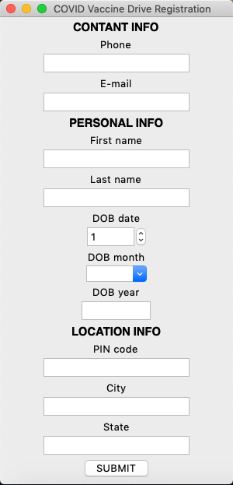

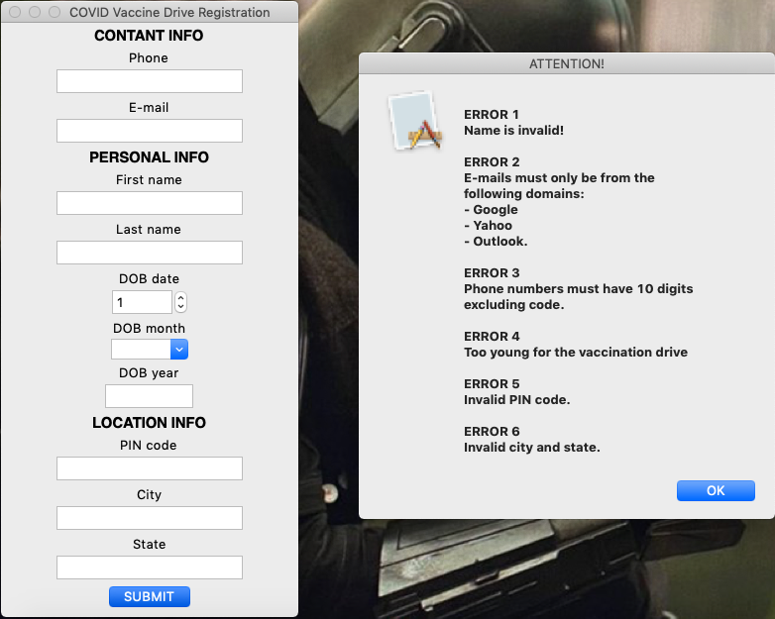

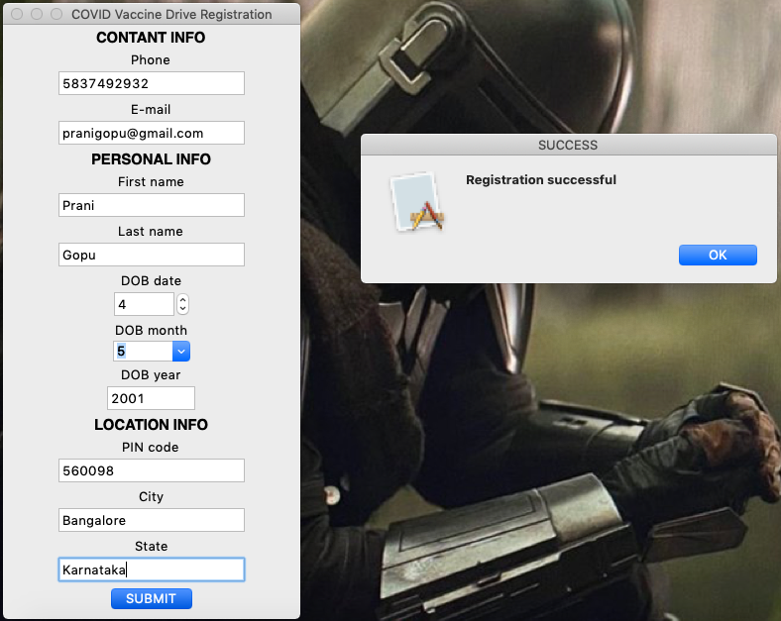

# Program 2: Loan Amount Eligibility

## Code

"""

Details to enter

- Name (not vital ifno)

- DOB

- Salary (monthly)

"""

*# INTERFACE*

*# Libraries and modules required*

from tkinter import *

from tkinter.ttk import Combobox

from tkinter.ttk import Separator

*# Root window...*

root = Tk()

root.title("Loan amount eligibility")

root.geometry("300x300")

*#========================*

*# LABELS*

nameLabel = Label(root, text = "Name")

dobLabels = [

Label(root, text = "DOB date"),

Label(root, text = "DOB month"),

Label(root, text = "DOB year")]

salaryLabel = Label(root, text = "Salary")

*#========================*

*# INPUTS*

nameInput = Entry(root, width = 20)

dobInputs = [

Spinbox(root, from_ = 1, to = 31, width = 6, wrap = True),

Combobox(root, values = list(range(1, 13)), width = 6),

Entry(root, width = 9)]

salaryInput = Entry(root, width = 9)

*#========================*

*# PACKING WIDGETS*

nameLabel.pack()

nameInput.pack()

for i in range(len(dobLabels)):

dobLabels[i].pack()

dobInputs[i].pack()

salaryLabel.pack()

salaryInput.pack()

*#========================*

*# SUBMISSION*

from re import *

from datetime import date

from tkinter import messagebox

**def** getAge():

try:

d = int(dobInputs[0].get())

m = int(dobInputs[1].get())

y = int(dobInputs[2].get())

except: return False

cur = date.today()

age = cur.year - y

if m < cur.month: age = age - 1

elif m == cur.month:

if d < cur.date: age = age - 1

return age

**def** loanAmt():

age = getAge()

try: salary = float(salaryInput.get())

except: return -1

a1, a2 = 0, 0

if salary >= 50000: a1 = 300000

elif salary >= 30000: a1 = 200000

elif salary >= 15000: a1 = 100000

if age >= 30: a2 = 100000

elif age >= 25: a2 = 200000

elif age >= 20: a2 = 300000

if a1 == 0 or a2 == 0: return -1

elif a1 < a2: return a1

else: return a2

**def** showAmt():

a = loanAmt()

if a == -1:

messagebox.showerror("NO LOAN AMOUNT", "You are not eligible for any loan amount.")

else:

messagebox.showinfo("LOAN AMOUNT", "You are eligible for a loan of {0}.".format(a))

Button(root, text = "SUBMIT", command = showAmt).pack()

*#========================*

mainloop()

## Output

